DEPARTMENT OF COMPUTER SCIENCE AND ENGINEERING
DATABASE MANAGEMENT SYSTEM (UCS 310)



SUBMITTED TO SUBMITTED BY
LAKSHAY SINGH
1024030975
ABHAYRAJ SINGH
1024030975
INDEX
S. No. | Contents
1 | Title Page
2 | Introduction
3 | Problem Statement
4 | Objectives of the Project
5 | Scope of the Project
6 | Proposed System Description
7 | Database Design
7.1 | Entity–Relationship (ER) Diagram
7.2 | Relational Schema
7.3 | ER to Relational Schema Mapping
8 | Normalization
9 | Database Implementation
9.1 | SQL Implementation
9.1.1 | Database Creation
9.1.2 | Table Creation (DDL Commands)
9.1.3 | Data Insertion (DML Commands)
9.1.4 | SELECT Queries
9.2 | PL/SQL Components
9.2.1 | Stored Procedure
9.2.2 | Function
9.2.3 | Trigger
9.2.4 | Cursor and Exception Handling
10 | Transaction Management & Concurrency Control
11 | Tools & Technologies Used
12 | Expected Outcomes
13 | Conclusion

INTRODUCTION
Recruitment processes in organizations often involve manually reviewing a large number of resumes, which is time-consuming and inefficient. With the increasing number of job applications, it becomes difficult to evaluate candidates accurately and consistently.
The Automated Resume Shortlisting System is designed to manage candidate data, job postings, applications, and shortlisting decisions using a structured database approach. The system focuses on backend database implementation using SQL and PL/SQL to ensure data consistency, automation, and efficient retrieval.
Motivation
The motivation behind selecting this project is to:
- Reduce manual effort in resume screening.
- Eliminate redundancy and data inconsistency.
- Automate shortlisting decisions using database procedures.
- Apply core DBMS concepts in a real-world scenario.
Importance of DBMS over File-Based System
Compared to a traditional file-based system, a DBMS provides:
- Reduced data redundancy
- Improved data integrity
- Efficient querying using SQL
- Multi-user support
- Transaction management with ACID properties
Thus, using a DBMS ensures structured and reliable management of recruitment data.

PROBLEM STATEMENT
Problem Definition
Organizations receive numerous job applications for various job roles. Manually managing candidate details, skills, experience, and shortlisting decisions leads to inefficiency, inconsistency, and errors.
The system aims to design a database that:
- Stores candidate profiles
- Manages job postings
- Tracks applications
- Automates shortlisting decisions
Limitations of Existing Manual System
- High time consumption
- Human errors in evaluation
- Duplicate records
- Lack of structured data storage
- Difficulty in generating reports
Scope of Database Usage
The database will:
- Store and organize candidate and job data
- Establish relationships between entities
- Enable automated evaluation using stored procedures
- Ensure consistency using constraints and triggers

Objectives of the Project

The main objectives of the Automated Resume Shortlisting System are:
- To design a structured database using Entity–Relationship (ER) modeling to represent candidates, jobs, applications, and shortlisting processes.
- To convert the ER model into well-defined relational schemas with proper primary and foreign key constraints.
- To apply normalization techniques up to Third Normal Form (3NF) in order to eliminate redundancy and ensure data consistency.
- To implement database structures and operations using SQL, including DDL and DML commands.
- To develop automation logic using PL/SQL constructs such as stored procedures, functions, triggers, and cursors.
- To ensure data integrity and reliability using constraints, transactions, and ACID properties.

Scope of the Project
The scope of the Automated Resume Shortlisting System is focused primarily on backend database design and implementation using SQL and PL/SQL. The system is designed to manage candidate profiles, job postings, applications, and automated shortlisting decisions in a structured and normalized database environment.
The project covers the following functional boundaries:
- Storage and management of candidate details including skills, experience, and projects.
- Management of job postings with required qualifications and minimum experience.
- Handling of job applications submitted by candidates.
- Automated shortlisting of candidates based on predefined evaluation logic.
- Updating application status using triggers and stored procedures.
The system supports two primary types of users:
- Administrator/Recruiter:
Responsible for adding job postings, reviewing applications, and viewing shortlisted candidates.
- Candidate:
Responsible for submitting applications and maintaining profile information.
The project is limited to backend database implementation. A web-based user interface is considered as a future enhancement and is not included in the current scope. The primary emphasis remains on database modeling, normalization, SQL queries, and procedural automation.

Proposed System Description
The proposed Automated Resume Shortlisting System is a database-driven system designed to efficiently manage recruitment data and automate candidate evaluation. The system uses a centralized relational database to store structured information about candidates, skills, experiences, projects, job postings, applications, and shortlisting results.
The working of the system can be described in the following steps:
- Candidate Registration and Profile Storage:
Candidate details such as personal information, skills, work experience, and projects are stored in separate normalized tables. This ensures elimination of redundancy and better data organization.
- Job Creation and Management:
Recruiters create job postings specifying job titles and minimum experience requirements. These job records are stored in the JOB table.
- Application Submission:
Candidates apply for specific job roles. Each application is stored in the APPLICATION table, maintaining relationships between candidates and jobs.
- Automated Evaluation:
A stored procedure is used to evaluate applications and assign a score based on predefined logic. Based on the score, candidates are marked as "Selected" or "Rejected."
- Status Update using Trigger:
A database trigger automatically updates the application status after a shortlisting decision is inserted into the SHORTLIST table.
The system improves efficiency by automating the evaluation process and reducing manual intervention. It ensures consistency through the use of primary keys, foreign keys, constraints, and normalization. Transaction management techniques further ensure reliability and data integrity.
The proposed design is scalable and can be extended with a web-based interface in the future to allow real-time interaction with users.

Entity–Relationship Diagram
The Entity–Relationship (ER) diagram represents the logical structure of the Automated Resume Shortlisting System. It models real-world entities involved in recruitment and defines relationships between them.
The following entities are identified in the system:
Entities
- Candidate
Stores personal and academic details of job applicants.
- Skill
Stores technical skills such as Java, Python, SQL, etc.
- Experience
Stores previous work experience details of candidates.
- Project
Stores academic or professional projects completed by candidates.
- Job
Stores job postings and minimum experience requirements.
- Application
Represents applications submitted by candidates for specific jobs.
- Shortlist
Stores evaluation results including score and decision.
Relationships
The relationships between the entities are as follows:
- A Candidate possesses multiple Skills (Many-to-Many).
- A Candidate has multiple Experiences (One-to-Many).
- A Candidate has multiple Projects (One-to-Many).
- A Candidate submits multiple Applications (One-to-Many).
- Each Application corresponds to one Job (Many-to-One).
- Each Application generates one Shortlist record (One-to-One).
Primary keys uniquely identify each entity, while foreign keys establish relationships between related tables.
ER Diagram
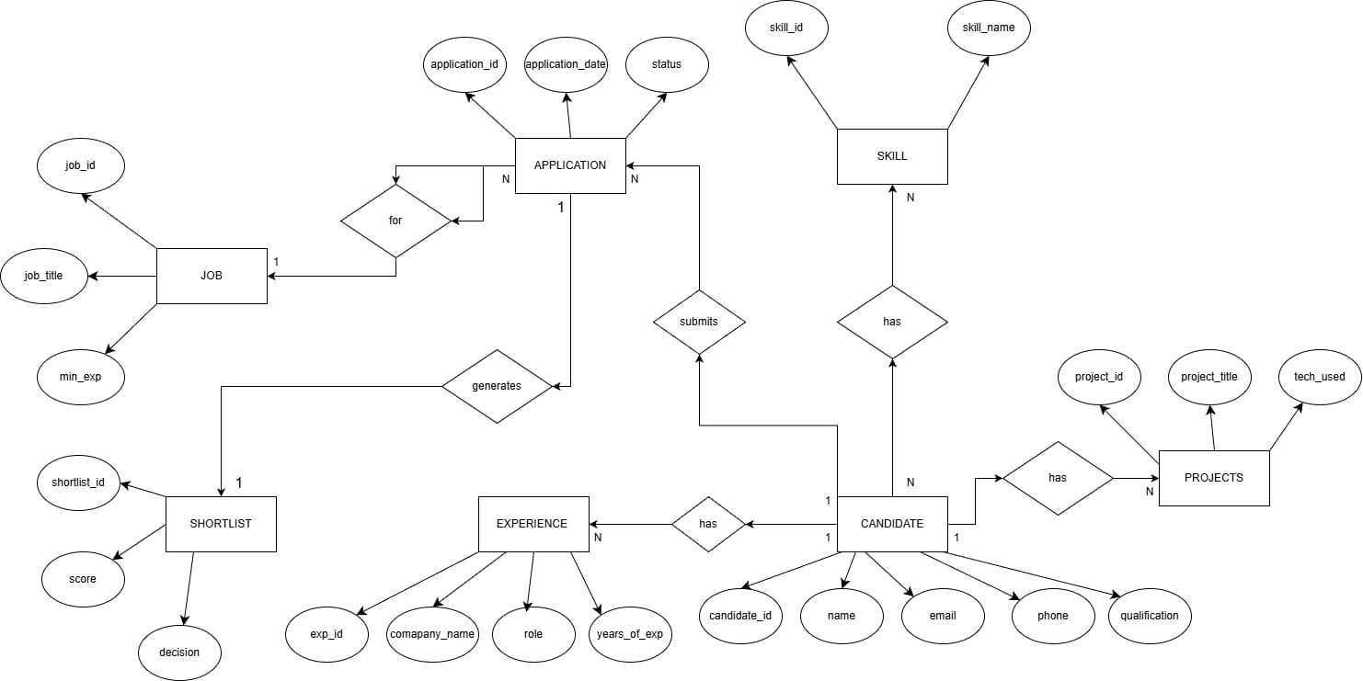
ER / EER DIAGRAM (Relationship Summary Table)
ER Diagram Contains the Following Relationships
Entity 1 | Name of Relationship | Entity 2 | Cardinality
Candidate | has | Skill | m : n
Candidate | has | Experience | 1 : n
Candidate | has | Project | 1 : n
Candidate | submits | Application | 1 : n
Application | for | Job | n : 1
Application | generates | Shortlist | 1 : 1

Relational Schema
The ER model is converted into the following relational schema:
CANDIDATE
(Candidate_ID PK, Name, Email, Phone, Qualification)
SKILL
(Skill_ID PK, Skill_Name)
CANDIDATE_SKILL
(Candidate_ID FK, Skill_ID FK)
EXPERIENCE
(Exp_ID PK, Candidate_ID FK, Company_Name, Role, Years_Of_Experience)
PROJECT
(Project_ID PK, Candidate_ID FK, Project_Title, Technologies_Used)
JOB
(Job_ID PK, Job_Title, Min_Experience)
APPLICATION
(Application_ID PK, Candidate_ID FK, Job_ID FK, Application_Date, Status)
SHORTLIST
(Shortlist_ID PK, Application_ID FK, Score, Decision)

The relational schema ensures proper mapping of entities and relationships while maintaining referential integrity through foreign key constraints.

Type of Binary Relationship | Relationships in the System
one-to-one (1:1) | Each application generates only one shortlist decision.
one-to-many (1:n) | (1) A candidate can have multiple experiences. (2) A candidate can work on multiple projects. (3) A candidate can submit multiple applications.
many-to-many (m:n) | A candidate can possess multiple skills and a skill can belong to multiple candidates.

ER to Relational Schema Mapping
The Entity–Relationship (ER) model is converted into relational tables using standard ER-to-relational mapping rules. Each entity and relationship in the ER diagram is transformed into corresponding relations with appropriate primary and foreign keys.
The mapping is described below:
1.Mapping of Strong Entities
Each strong entity in the ER diagram is converted into a separate relation. The primary key of the entity becomes the primary key of the relation.
ER Entity | Relational Table
Candidate | CANDIDATE(candidate_id, name, email, phone, qualification)
Skill | SKILL(skill_id, skill_name)
Experience | EXPERIENCE(exp_id, candidate_id, company_name, role, years_of_experience)
Project | PROJECT(project_id, candidate_id, project_title, technologies_used)
Job | JOB(job_id, job_title, min_experience)
Application | APPLICATION(application_id, candidate_id, job_id, application_date, status)
Shortlist | SHORTLIST(shortlist_id, application_id, score, decision)
2.Mapping of One-to-Many (1:N) Relationships
In a one-to-many relationship, the primary key of the “one” side is added as a foreign key in the “many” side.
Relationship | Implementation
Candidate — Experience | candidate_id added as FK in EXPERIENCE
Candidate — Project | candidate_id added as FK in PROJECT
Candidate — Application | candidate_id added as FK in APPLICATION
Job — Application | job_id added as FK in APPLICATION
Application — Shortlist | application_id added as FK in SHORTLIST

3.Mapping of Many-to-Many (M:N) Relationship
The many-to-many relationship between Candidate and Skill is resolved by creating a new relation.
ER Relationship | Relational Table
Candidate — Skill | CANDIDATE_SKILL(candidate_id, skill_id)

4.Mapping of One-to-One (1:1) Relationship
The relationship between Application and Shortlist is one-to-one.
This is implemented by adding application_id as a foreign key in the SHORTLIST table.
This ensures that:
- Each application generates only one shortlisting decision.
- Referential integrity is maintained.
Integrity Constraints Applied
The following constraints were implemented:
- Primary Key constraints to uniquely identify records.
- Foreign Key constraints to maintain relationships.
- AUTO_INCREMENT for system-generated shortlist_id.
- NOT NULL constraints where required.

The ER model was successfully transformed into a relational schema using standard mapping techniques. The resulting schema maintains data consistency, eliminates redundancy, and ensures efficient query processing.

Normalization

Normalization is the process of organizing data in a database to reduce redundancy and improve data integrity. The proposed database for the Automated Resume Shortlisting System has been normalized up to Third Normal Form (3NF).

First Normal Form (1NF)
A relation is in First Normal Form if:
- All attributes contain atomic (indivisible) values.
- There are no repeating groups or multivalued attributes.
In the proposed system:
- Skills, projects, and experiences are stored in separate tables.
- No column contains multiple values in a single field.
- Each record is uniquely identified using a primary key.
Therefore, all tables satisfy First Normal Form (1NF).

Second Normal Form (2NF)
A relation is in Second Normal Form if:
- It is already in 1NF.
- All non-key attributes are fully functionally dependent on the entire primary key.
In this system:
- Tables such as CANDIDATE, SKILL, JOB, EXPERIENCE, PROJECT, and APPLICATION use single primary keys.
- The CANDIDATE_SKILL table resolves the many-to-many relationship and uses a composite key.
- There are no partial dependencies in any table.
Hence, the database satisfies Second Normal Form (2NF).
Third Normal Form (3NF)
A relation is in Third Normal Form if:
- It is already in 2NF.
- There are no transitive dependencies.
- Non-key attributes depend only on the primary key.
In the proposed schema:
- Candidate details are stored only in the CANDIDATE table.
- Job details are stored only in the JOB table.
- Skill information is maintained separately in the SKILL table.
- Experience and project information are stored independently.
No non-key attribute depends on another non-key attribute. Therefore, the database satisfies Third Normal Form (3NF).

Conclusion of Normalization
The final normalized structure eliminates redundancy, prevents update anomalies, and ensures data consistency. The database design is efficient and suitable for scalable implementation.
Functional Dependency |  | Violates
candidate_id → name, email, phone, qualification |  | No violation
skill_id → skill_name |  | No violation
exp_id → company_name, role, years_of_experience |  | No violation
project_id → project_title, technologies_used |  | No violation
job_id → job_title, min_experience |  | No violation
application_id → candidate_id, job_id, application_date, status |  | No violation
application_id → score, decision | Removed via Shortlist table (avoids transitive dependency)
NORMALIZATION RULES ON DATABASE
Normalizing Tables into 3NF
Tables After Normalization

CANDIDATE (candidate_id, name, email, phone, qualification)

SKILL (skill_id, skill_name)

CANDIDATE_SKILL (candidate_id, skill_id)

EXPERIENCE (exp_id, candidate_id, company_name, role, years_of_experience)

PROJECT (project_id, candidate_id, project_title, technologies_used)

JOB (job_id, job_title, min_experience)

APPLICATION (application_id, candidate_id, job_id, application_date, status)

SHORTLIST (shortlist_id, application_id, score, decision)

SQL Implementation
The database was implemented using MySQL. Structured Query Language (SQL) was used for defining the schema, inserting data, and retrieving information.
Database Creation
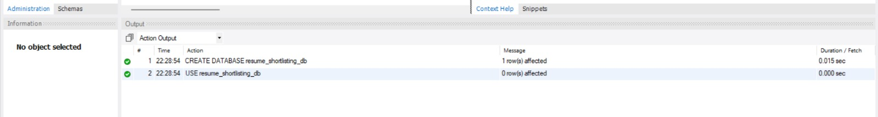
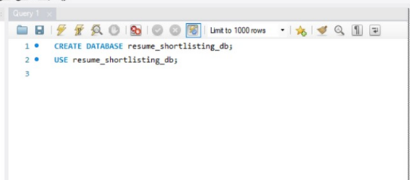
Table Creation (DDL Commands)
Candidate Table
Tables were created using CREATE TABLE statements with appropriate primary and foreign key constraints to maintain referential integrity.
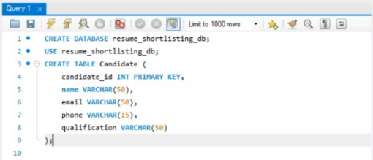
Skill Table
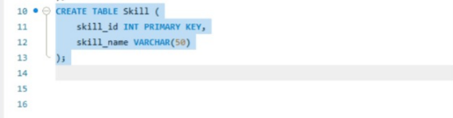
CREATE TABLE skill (
skill_id INT PRIMARY KEY,
skill_name VARCHAR(50)
);
Candidate_Skill Table
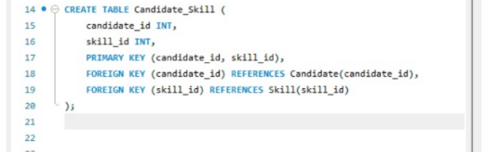

CREATE TABLE candidate_skill (
candidate_id INT,
skill_id INT,
PRIMARY KEY (candidate_id, skill_id),
FOREIGN KEY (candidate_id) REFERENCES candidate(candidate_id),
FOREIGN KEY (skill_id) REFERENCES skill(skill_id));
Experience Table
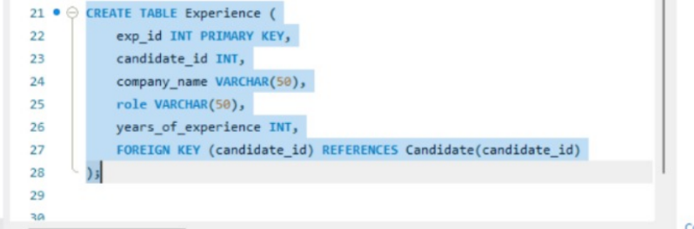

Project Table
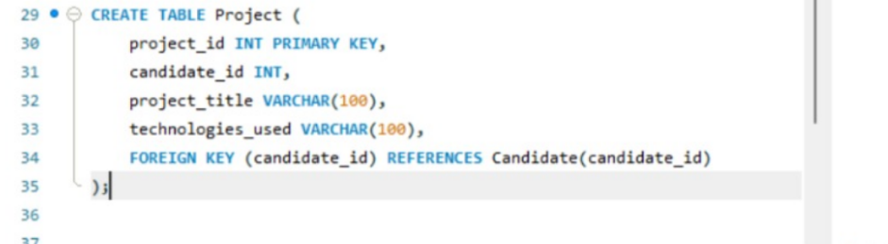
CREATE TABLE project (
project_id INT PRIMARY KEY,
candidate_id INT,
project_title VARCHAR(100),
technologies_used VARCHAR(100),
FOREIGN KEY (candidate_id) REFERENCES candidate(candidate_id)
);

Job Table
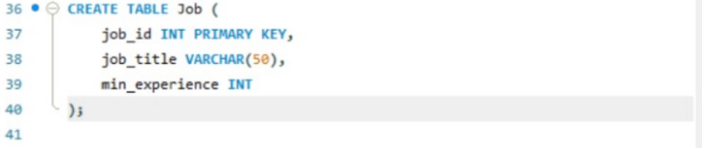
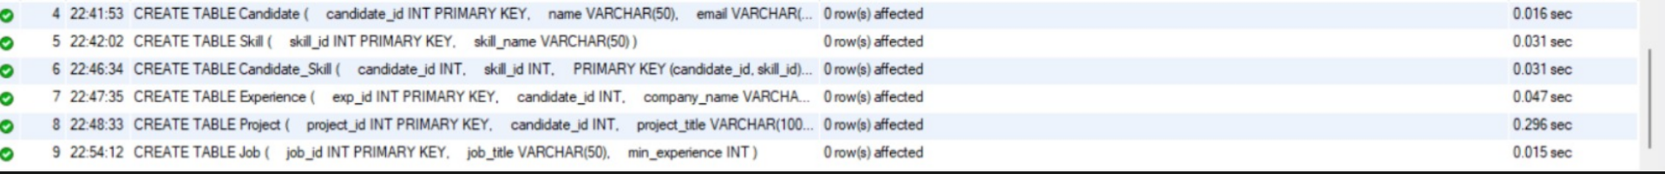
Application Table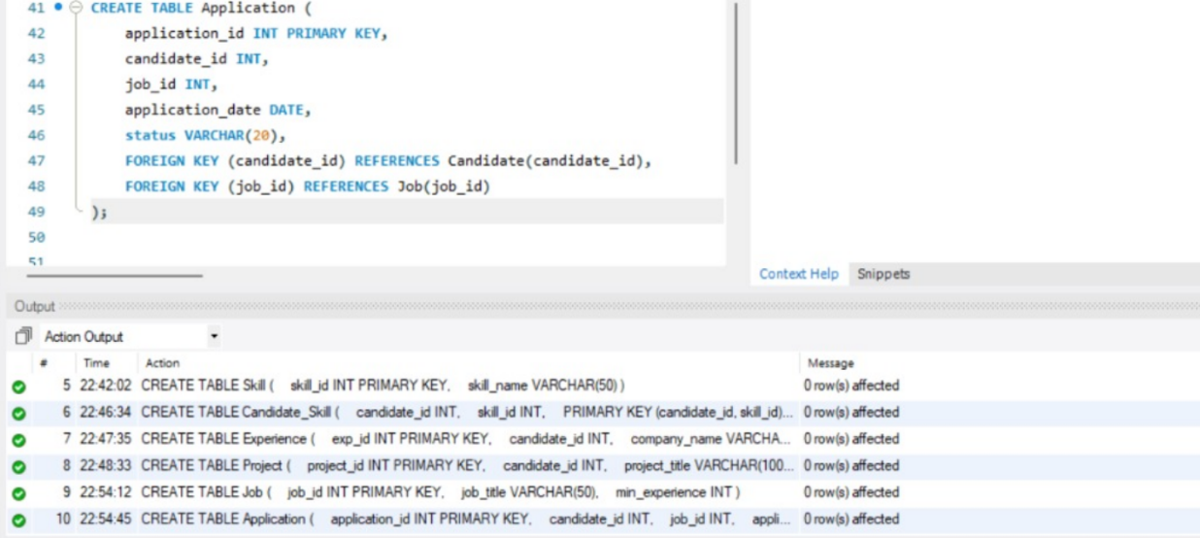
CREATE TABLE application (
application_id INT PRIMARY KEY,
candidate_id INT,
job_id INT,
application_date DATE,
status VARCHAR(20),
FOREIGN KEY (candidate_id) REFERENCES candidate(candidate_id),
FOREIGN KEY (job_id) REFERENCES job(job_id));
Shortlist Table
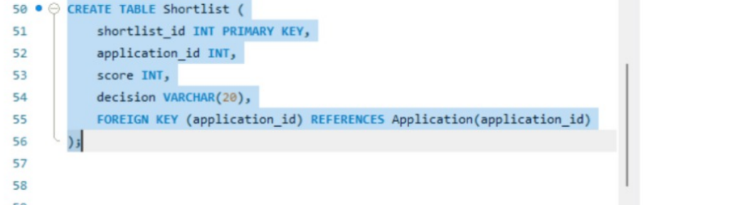
CREATE TABLE shortlist (
shortlist_id INT AUTO_INCREMENT PRIMARY KEY,
application_id INT,
score INT,
decision VARCHAR(20),
FOREIGN KEY (application_id) REFERENCES application(application_id)
);

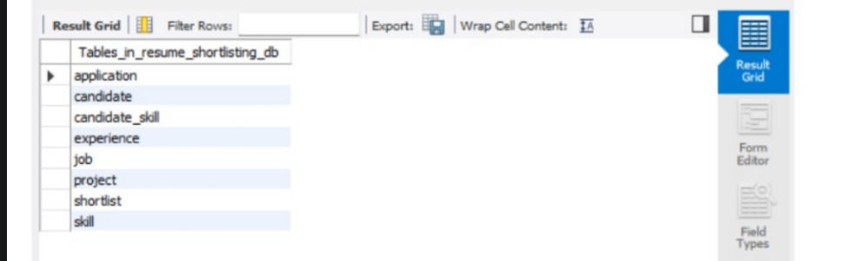

Data Insertion (DML Commands)
Sample data was inserted into each table to simulate real-world recruitment scenarios.
Insert into Skill
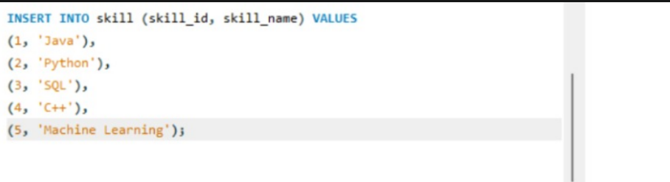
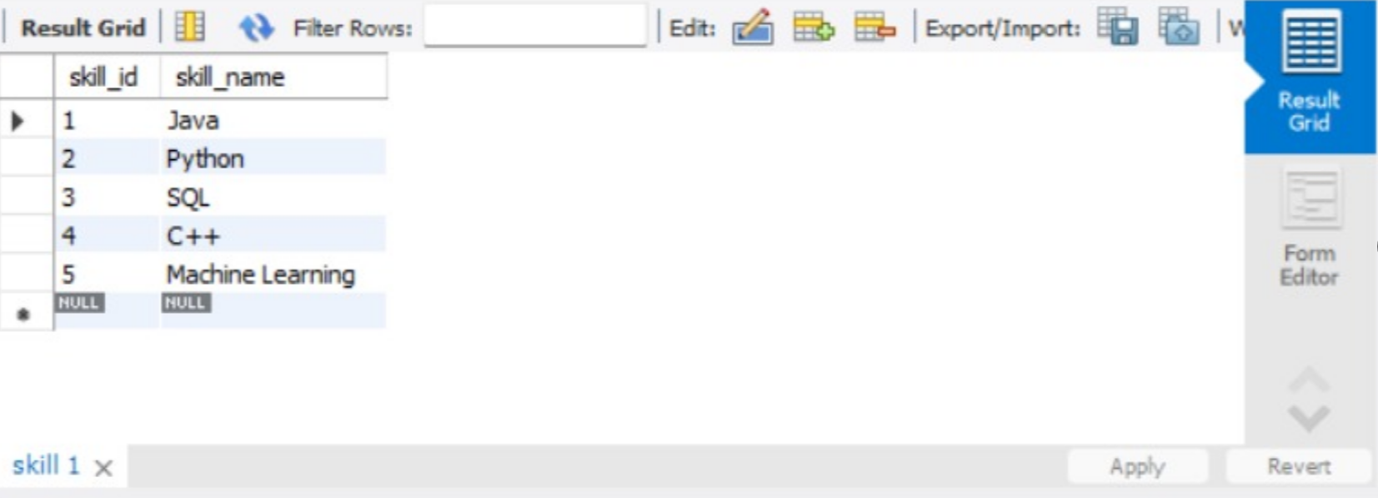

Insert into Candidate
INSERT INTO candidate VALUES
(101, 'Lakshay Singh', 'lakshay@gmail.com', '9995559999', 'B.Tech'),
(102, 'Abhayraj Singh', 'abhay@gmail.com', '8888888000', 'B.Tech'),
(103, 'Rohit Sharma', 'rohit@gmail.com', '7776767677', 'B.Tech');
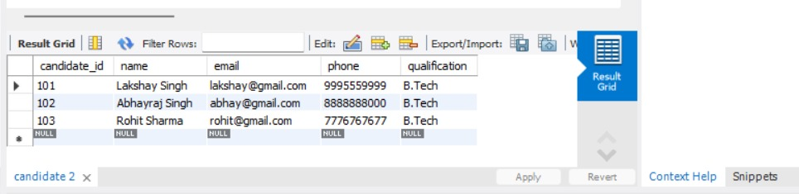
Insert into Candidate_Skill
INSERT INTO candidate_skill VALUES
(101, 1),
(101, 3),
(102, 2),
(102, 3),
(103, 1),
(103, 5);
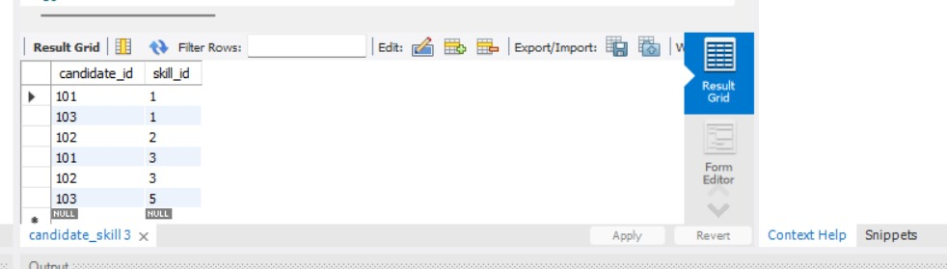

Insert into Experience
INSERT INTO experience VALUES
(1, 101, 'ABC Corp', 'Software Intern', 1),
(2, 102, 'XYZ Ltd', 'Python Developer', 2),
(3, 103, 'TechSoft', 'ML Engineer', 3);
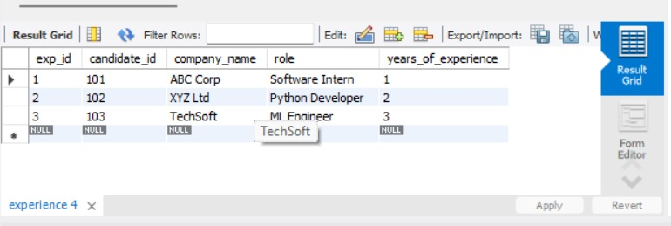
Insert into Project
INSERT INTO project VALUES
(201, 101, 'Resume Parser', 'Java, SQL'),
(202, 102, 'Web Scraper', 'Python'),
(203, 103, 'Job Recommendation System', 'Python, ML');
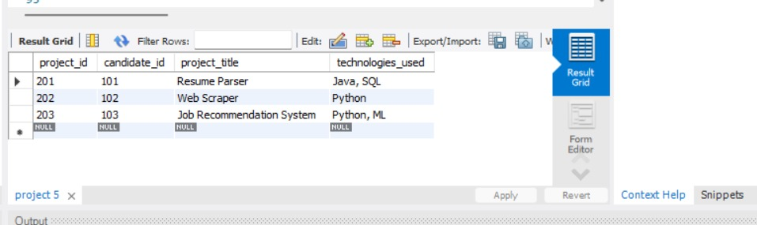

Insert into Job
INSERT INTO job VALUES
(301, 'Software Engineer', 1),
(302, 'Data Analyst', 2),
(303, 'ML Engineer', 3);
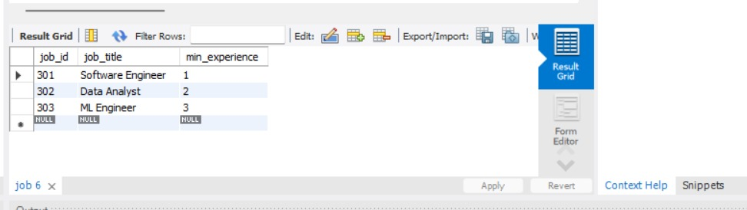
Insert into Application
INSERT INTO application VALUES
(401, 101, 301, '2024-03-01', 'Applied'),
(402, 102, 302, '2024-03-02', 'Applied'),
(403, 103, 303, '2024-03-03', 'Applied');
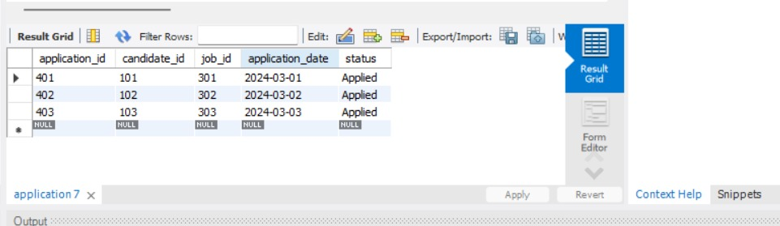

Insert into Shortlist
INSERT INTO shortlist (application_id, score, decision) VALUES
(401, 85, 'Selected'),
(402, 78, 'Selected'),
(403, 65, 'Selected');
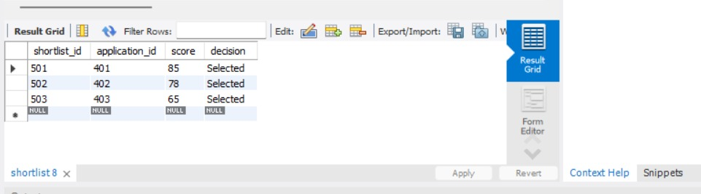

SELECT Queries
Various SELECT queries were executed to retrieve meaningful information from the database.

Join Query
SELECT c.name, s.skill_name
FROM candidate c
JOIN candidate_skill cs ON c.candidate_id = cs.candidate_id
JOIN skill s ON cs.skill_id = s.skill_id;
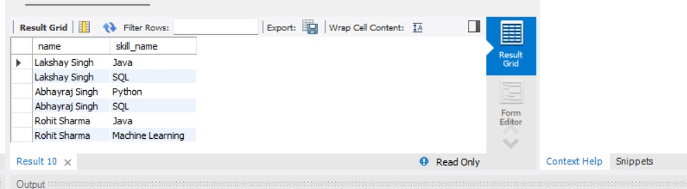
JOIN + WHERE
SELECT c.name, j.job_title
FROM candidate c
JOIN application a ON c.candidate_id = a.candidate_id
JOIN job j ON a.job_id = j.job_id
WHERE j.job_title = 'Software Engineer';
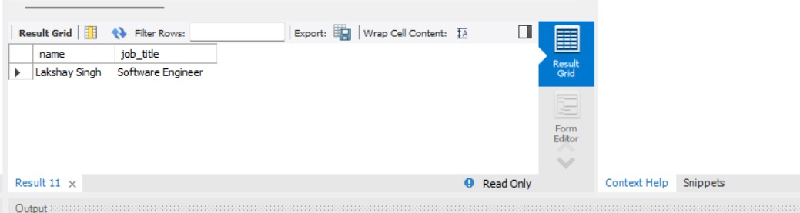
AGGREGATE
SELECT job_id, COUNT(application_id) AS total_applications
FROM application
GROUP BY job_id;
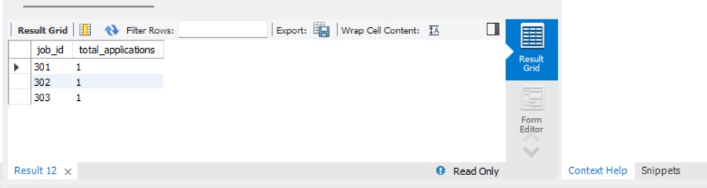
This query counts the number of applications received for each job.
HAVING clause
SELECT job_id, COUNT(application_id) AS total_applications
FROM application
GROUP BY job_id
HAVING COUNT(application_id) >= 1;
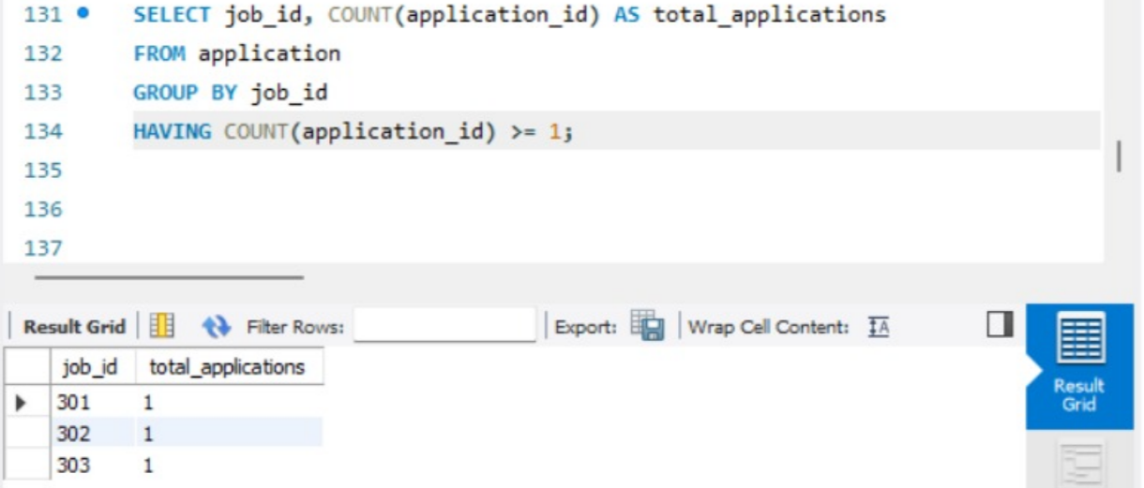

SUBQUERY
SELECT name
FROM candidate
WHERE candidate_id IN (
SELECT candidate_id
FROM application
WHERE job_id = 301
);
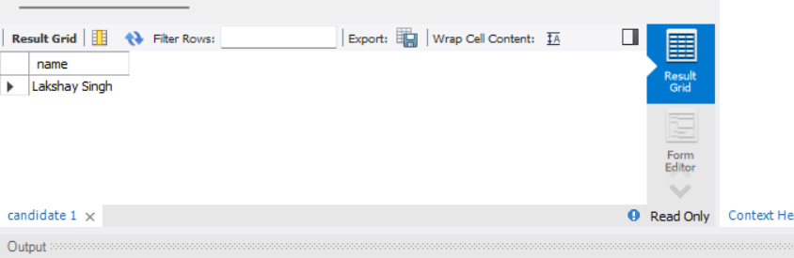

SHORTLIST RESULT
SELECT c.name, s.score, s.decision
FROM candidate c
JOIN application a ON c.candidate_id = a.candidate_id
JOIN shortlist s ON a.application_id = s.application_id;
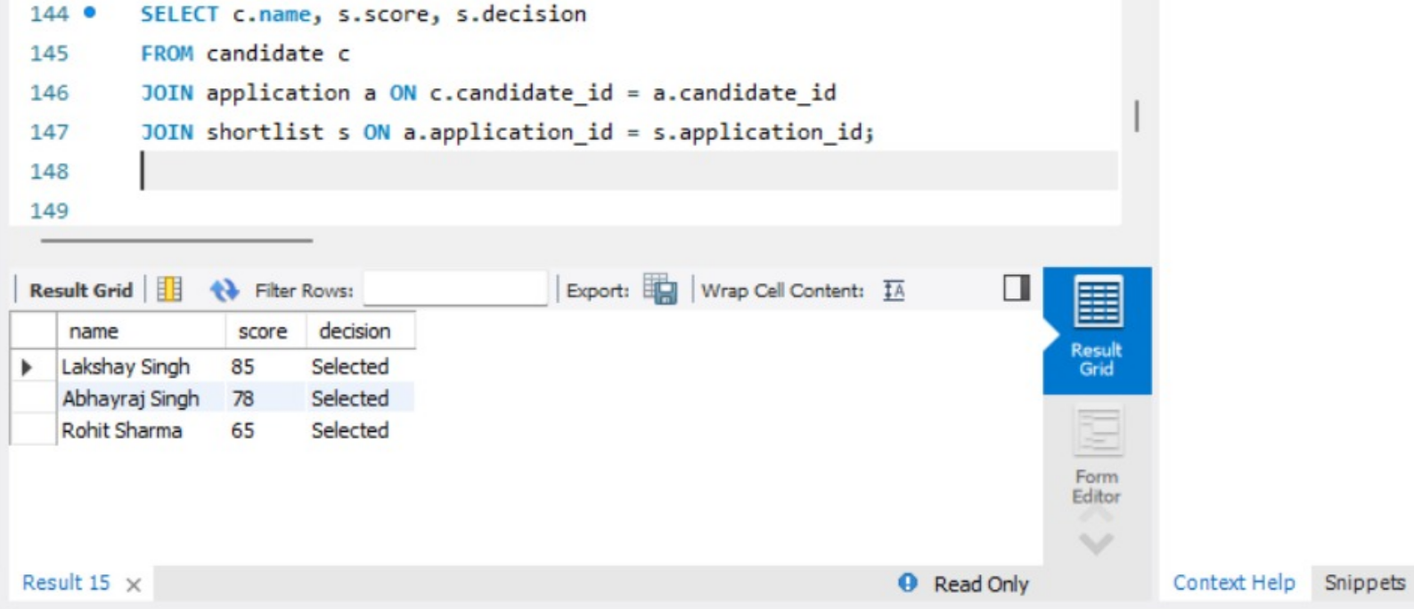
VIEW
CREATE VIEW selected_candidates AS
SELECT c.name, j.job_title, s.score
FROM candidate c
JOIN application a ON c.candidate_id = a.candidate_id
JOIN job j ON a.job_id = j.job_id
JOIN shortlist s ON a.application_id = s.application_id
WHERE s.decision = 'Selected';
SELECT * FROM selected_candidates;

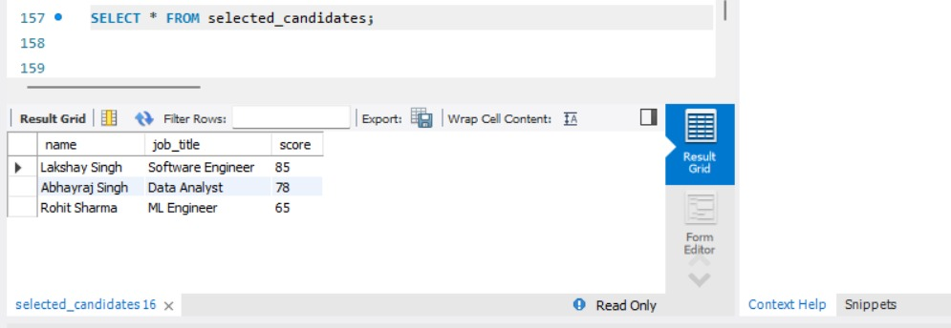
PL/SQL COMPONENTS
1.STORED PROCEDURE
DELIMITER $$

CREATE PROCEDURE evaluate_application(IN app_id INT)
BEGIN
DECLARE app_score INT;

-- Simple evaluation logic
SET app_score = FLOOR(60 + RAND() * 40);

IF app_score >= 70 THEN
INSERT INTO shortlist VALUES
(NULL, app_id, app_score, 'Selected');
ELSE
INSERT INTO shortlist VALUES
(NULL, app_id, app_score, 'Rejected');
END IF;
END $$

DELIMITER ;
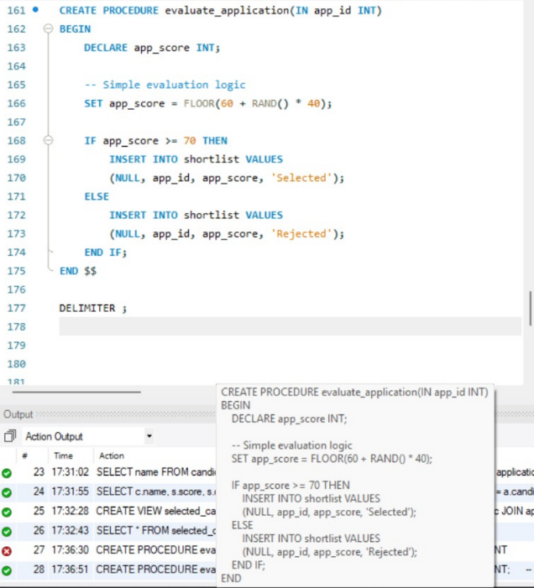

CALL evaluate_application(401);
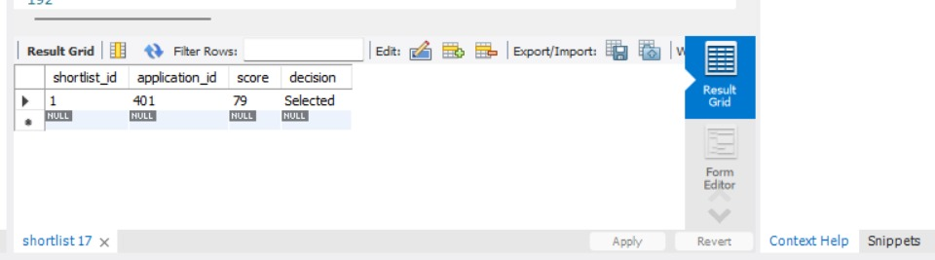
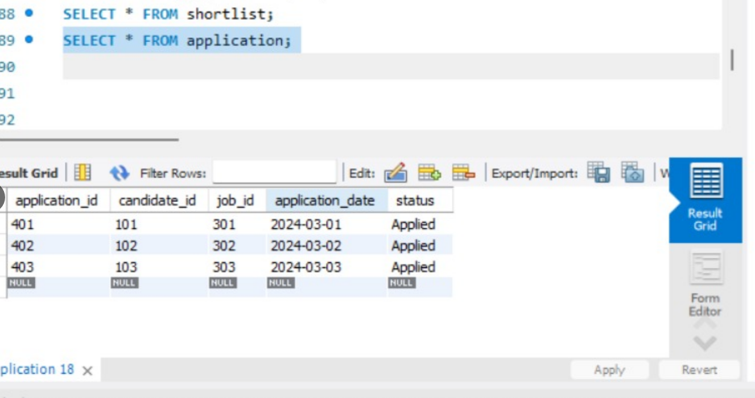

2.FUNCTION
DELIMITER $$

CREATE FUNCTION calculate_score(exp INT)
RETURNS INT
DETERMINISTIC
BEGIN
RETURN exp * 20;
END $$

DELIMITER ;
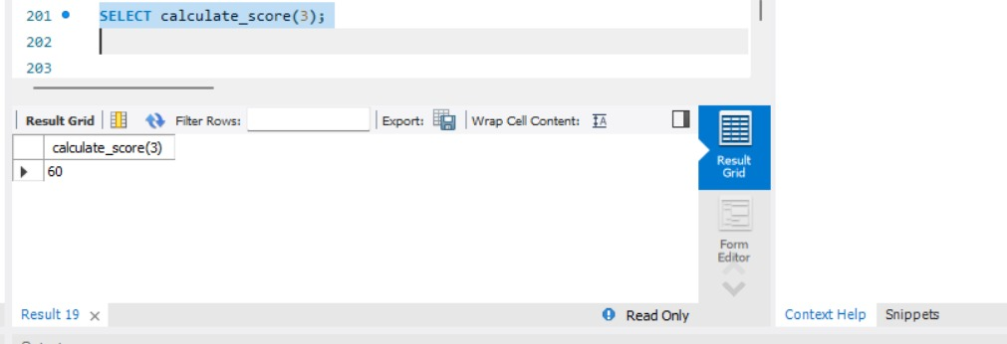

3.TRIGGER
DELIMITER $$

CREATE TRIGGER update_application_status
AFTER INSERT ON shortlist
FOR EACH ROW
BEGIN
UPDATE application
SET status = NEW.decision
WHERE application_id = NEW.application_id;
END $$

DELIMITER ;
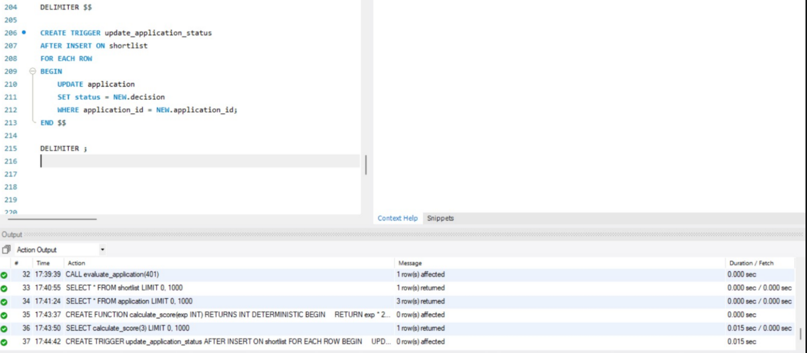

4.CURSOR
DELIMITER $$
CREATE PROCEDURE process_all_applications()
BEGIN
DECLARE done INT DEFAULT 0;
DECLARE aid INT;

DECLARE app_cursor CURSOR FOR
SELECT application_id FROM application;

DECLARE CONTINUE HANDLER FOR NOT FOUND SET done = 1;

OPEN app_cursor;

read_loop: LOOP
FETCH app_cursor INTO aid;
IF done = 1 THEN
LEAVE read_loop;
END IF;
CALL evaluate_application(aid);
END LOOP;

CLOSE app_cursor;
END $$

DELIMITER ;
Transaction Management & Concurrency Control
10.1 Transaction Management
A transaction is a logical unit of work that consists of one or more SQL operations executed as a single unit. In the Automated Resume Shortlisting System, transaction management ensures that database operations are performed reliably and consistently.
To maintain database integrity, the system follows the ACID properties:
ACID Properties
1. Atomicity
Ensures that all operations within a transaction are completed successfully. If any operation fails, the entire transaction is rolled back.
2. Consistency
Ensures that the database moves from one valid state to another after a transaction.
3. Isolation
Ensures that concurrent transactions do not interfere with each other.
4. Durability
Ensures that once a transaction is committed, the changes are permanently stored in the database.
Transaction Commands Used
START TRANSACTION;
SAVEPOINT sp1;
ROLLBACK TO sp1;
COMMIT;
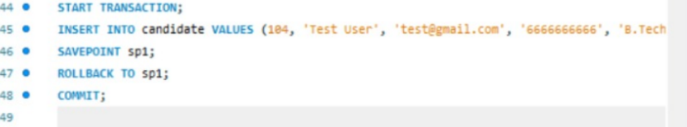
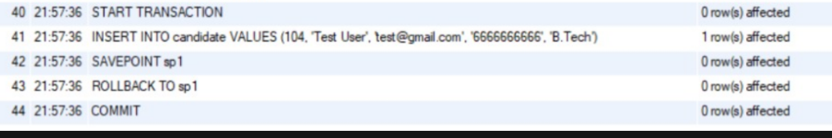
Concurrency Control
Concurrency control ensures that multiple users accessing the database simultaneously do not cause inconsistency.
MySQL handles concurrency using:
- Row-level locking
- Isolation levels
- Transaction control mechanisms
In this project, foreign key constraints and transaction commands help maintain data integrity during concurrent operations.

Conclusion
Transaction management and concurrency control mechanisms ensure reliability, consistency, and fault tolerance in the Automated Resume Shortlisting System.

Tools & Technologies Used
The Automated Resume Shortlisting System was implemented using the following tools and technologies:
1.Database Management System
MySQL 8.0
MySQL was used as the relational database management system for storing and managing structured recruitment data. It supports SQL queries, constraints, transactions, and procedural extensions.

2.Query and Development Tool
MySQL Workbench
MySQL Workbench was used for:
- Writing and executing SQL queries
- Creating and managing tables
- Implementing stored procedures, functions, triggers, and cursors
- Visualizing database schema

3.Query Language
Structured Query Language (SQL)
SQL was used for:
- Data Definition Language (DDL) commands
- Data Manipulation Language (DML) commands
- SELECT queries with joins, subqueries, and aggregate functions

4.Procedural Extension
MySQL Stored Procedures (PL/SQL equivalent)
Procedural logic was implemented using:
- Stored Procedures
- Functions
- Triggers
- Cursors
- Exception handling mechanisms
These components enhanced automation and backend logic implementation.

5.Diagram Tool
draw.io / Online ER Diagram Tool
An ER diagram tool was used to design and visualize the Entity–Relationship model before converting it into relational schema.

6.Operating System
Windows Operating System
The implementation was performed on a Windows-based environment.

Conclusion
The combination of MySQL and SQL provided a robust backend environment for implementing the Automated Resume Shortlisting System with proper database design, automation, and integrity constraints.

Expected Outcomes
The Automated Resume Shortlisting System is expected to achieve the following outcomes:
- Structured Data Management
Successful creation of a normalized relational database to store candidate, job, and application information efficiently.
- Reduction of Redundancy
Elimination of duplicate and inconsistent data through normalization up to Third Normal Form (3NF).
- Efficient Data Retrieval
Implementation of optimized SQL queries including joins, subqueries, aggregate functions, GROUP BY, HAVING, and views for meaningful data extraction.
- Automation of Evaluation Process
Automatic shortlisting of candidates using stored procedures, functions, and triggers to reduce manual intervention.
- Improved Data Integrity
Maintenance of referential integrity using primary key and foreign key constraints.
- Reliable Transaction Handling
Use of transaction control mechanisms to ensure safe and consistent database operations.
- Scalability for Future Integration
The database design allows future integration with a web-based interface for real-time user interaction.

Final Conclusion
The project successfully demonstrates the practical implementation of core Database Management System concepts including ER modeling, normalization, SQL queries, PL/SQL constructs, and transaction management. The system provides a scalable and efficient backend solution for automating resume shortlisting processes.

